# **HEALTHCARE PROJECT SQL QUERY**

## **KEY PERFORMANCE INDICATORS (KPI)**

**1. Total Revenue (Billing Amount)**

SELECT Round(SUM(Billing_Amount),2) AS Total_Revenue

FROM healthcare_dataset;

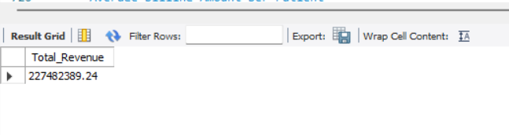

**2.Average Billing Amount per Patient**

SELECT round(AVG(Billing_Amount),2) AS Avg_Billing

FROM healthcare_dataset;

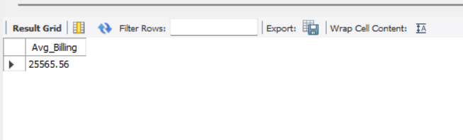

**3.Number of Admissions per Hospital**

SELECT Hospital, COUNT(*) AS Total_Admissions

FROM healthcare_dataset

GROUP BY Hospital

ORDER BY Total_Admissions DESC;

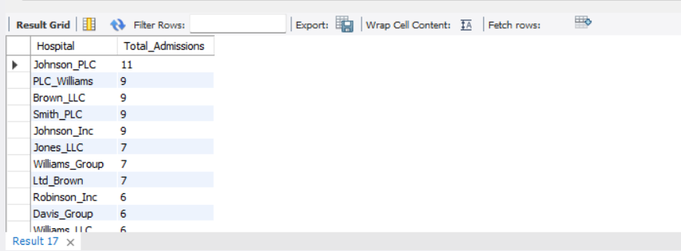

**4. Admissions by Type**

SELECT Admission_Type, COUNT(*) AS Total

FROM healthcare_dataset

GROUP BY Admission_Type;

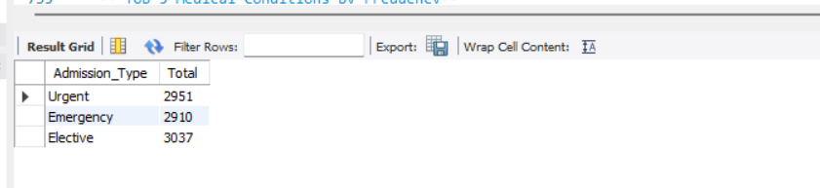

**5. Top 5 Medical Conditions by Frequency--**

SELECT Medical_Condition, COUNT(*) AS Count

FROM healthcare_dataset

GROUP BY Medical_Condition

ORDER BY Count DESC

LIMIT 5;

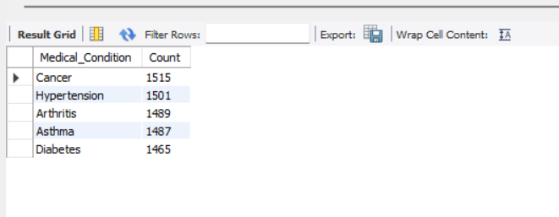

**6. Average Length of Stay (Assumes Dates are parsed correctly)--**

SELECT round(AVG(DATEDIFF(Discharge_Date, Date_of_Admission)),0) AS Avg_Stay_Days

FROM healthcare_dataset;

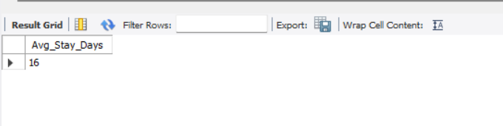

**6.Gender Distribution of Patients--**

select gender,count(*) as count from healthcare_dataset group by gender;

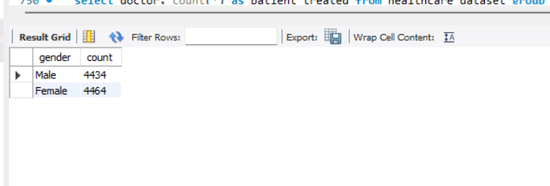

**7. Top 5 Doctors by Number of Patients Treated--**

select doctor, count(*) as patient_treated from healthcare_dataset group by Doctor order by patient_treated desc limit 5;

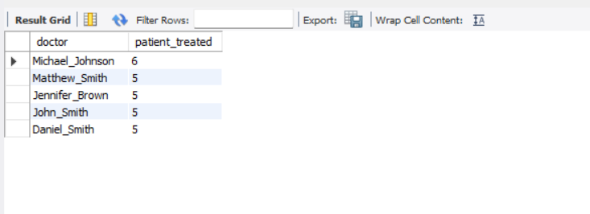

**8.Insurance Provider Utilization**

SELECT Insurance_Provider, COUNT(*) AS total

FROM healthcare_dataset

GROUP BY Insurance_Provider;

